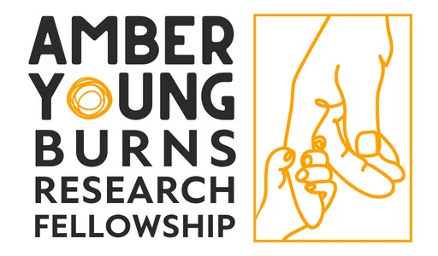
APPLICATION FORM
Please use the font size 12pt throughout. Please email one copy to eleanor@scarfree.org.uk by the closing date 5pm on the 31 July 2026
Due to the volume of applications we receive, applications which do not strictly follow the instructions in this form will be rejected.
- Personal Details
Title:
Surname:
Forename(s):
Address:

Post Code:
Email Address:
Phone Number:
Job Title:
Academic/Clinical Institution
Address:

Post Code:

- The Project
Project Title:
Proposed Start Date:
Duration:
Participating organisation/s: | Provide full contact details of each participating organisation, to include details of NHS sponsor (if applicable).
Describe the proposed research (maximum 1500 words). This section should include:
- Background.
- Research question.
- Programme of work.
- Relevance to scope of the Amber Young Research Fellowship, i.e. research which addresses key issues of clinical burn care for children and young people aged from birth to 18 years old.
- If applicable, relevance to the JLA Global Burns Research Priorities https://burnsresearch.bristol.ac.uk/
- Details of cross-service collaboration between England & Wales burns services to assist with the delivery of this project, if relevant.

(References are excluded from the word count).

Plain English summary: | Provide a lay/plain English summary suitable for a non-scientific/medical audience (maximum 250 words).

- Costings | (Provide a breakdown of costs for the project noting the various areas applied for).
Item:
Item:
Item:
Item:
Total

- Impact
How will this project ultimately benefit patients?
(maximum 350 words).

Provide information on how this research will increase your chances of attracting further grant support and the type of funding for which you intend to apply?
(maximum 250 words)

- Research Governance
Does this research involve animals? If yes, please email eleanor@scarfree.org.uk for further information.

Do you need approval from your Ethics Committee or R&D department? If yes, have you obtained the necessary approvals?

- Equity, Diversity and Inclusion (EDI)
Age  Do you consider yourself to have a disability or long-term condition?  Ethnic Background  Gender Identity  Do you identify as trans or have a trans history?  Barriers: | ☐ 18–24 ☐ 25–34 ☐ 35–44 ☐ 45–54 ☐ 55–64 ☐ 65+  ☐ Prefer not to say  Under the Equality Act 2010, a person is disabled if they have a physical or mental impairment which has a substantial and long-term adverse effect on their ability to carry out normal day-to-day activities  ☐ Yes ☐ No ☐ Prefer not to say  Categories based on Office for National Statistics classifications  ☐ White - English/Welsh/Scottish/Northern Irish/ British  ☐ White - Irish  ☐ White - Gypsy or Irish Traveller  ☐ White - Any other White background  ☐ Mixed or Multiple ethnic groups - White and Black Caribbean  ☐ Mixed or Multiple ethnic groups - White and Black African  ☐ Mixed or Multiple ethnic groups - White and Asian  ☐ Mixed or Multiple ethnic groups - Any other Mixed background  ☐ Asian or Asian British - Indian  ☐Asian or Asian British - Pakistani  ☐ Asian or Asian British - Bangladeshi  ☐ Asian or Asian British - Chinese  ☐ Asian or Asian British - Any other Asian background  ☐ Black, Black British, Caribbean or African - Caribbean  ☐ Black, Black British, Caribbean or African - African  ☐ Black, Black British, Caribbean or African - Any other Black background  ☐ Other ethnic group - Arab  ☐ Other ethnic group - Any other ethnic background (if not listed)  ☐ Woman ☐ Man ☐ Non-binary ☐ Prefer not to say  ☐ Self-described Gender  ☐ Yes ☐ No ☐ Prefer not to say  Please indicate any barriers you face in accessing opportunities  ☐ Economic disadvantage  ☐ Caring responsibilities  ☐ Geographic isolation  ☐ Accessibility (physical or digital)  ☐ Language or communication  ☐ Discrimination or bias  ☐ Other (please specify):

- Use of Artificial Intelligence (AI)
Has your application process been assisted by the use of AI at any stage? | Please refer to the Association of Medical Research Charities guidance on the use of AI:  https://www.amrc.org.uk/generative-ai-research-application-and-assessment  ☐ Yes ☐ No  If yes, please give details:

- Declarations
I accept that, if the planned research has not commenced within 6 months of the award of the Fellowship, then the grant will be withdrawn.

Signed:
Print Name:
Date:

Please email this application and your CV to Eleanor Kennedy (eleanor@scarfree.org.uk) by 5pm on the 31 July 2026

