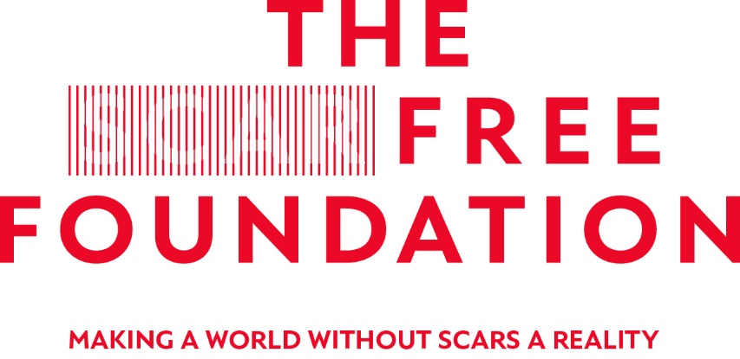
APPLICATION FOR A SCAR FREE FOUNDATION
ELECTIVE AWARD 2020
Please use the font size 12pt throughout. Please email one copy to Eleanor@scarfree.org.uk and forward one signed copy to Ellie Carden, Research Officer, The Scar Free Foundation, The Royal College of Surgeons of England, 35-43 Lincoln’s Inn Fields, London, WC2A 3PE, by the closing date 5pm on the 31 January 2020.
Due to the volume of applications we receive, applications which do not strictly follow the instructions in this form will be rejected.

- Personal Details
Title:
Surname:
Forenames:
Address:

Post Code:
Email Address:
Phone Number:

Academic Institution:
Year:

Medical ☐ | Psychology ☐ | Paramedic ☐ | Nursing ☐
Speech and ☐  Language | Dental ☐

Area of Study | Elective Supported by: (See Annex A for Eligibility Criteria)
Plastic and reconstructive surgery | The British Association of Plastic and Reconstructive Surgeons (BAPRAS)  ☐
Hand surgery | The British Society of Surgery of the Hand (BSSH)  ☐
Burn medicine and care | The British Burn Association (BBA)  ☐
Craniofacial medicine, care and treatment | The Craniofacial Society of Britain and Ireland (CFSGB&I)  ☐

Educational Qualifications (To include AS, A Levels and Higher Degrees)
Subject | Grade | Year
Honours, prizes or distinctions during the course of your undergraduate training

- Elective Details
Title of Project:
Details of institution and address:
Proposed dates of Elective:

- Purpose of your Elective
What are the objectives of your elective?

To include:
- Personal learning objectives
- Proposed research aims and objectives
- Research question

Max 500 words
Note: In your final report for the Elective (if successful) you will be asked to address these objectives in turn, it is therefore important they are achievable and have been developed in conjunction with your supervisor.
Please tell us how you plan to meet these objectives
Max 800 words
Note: To include plan of investigation and how learning objectives will be achieved.
References:

Does your Elective involve the use of interviews or questionnaires?
Yes ☐ | No ☐ | Not Applicable ☐
If you have ticked yes and your questionnaire/survey is to be administered on patients it is essential that it is approved by either an in-country or host institution ethics committee. Please use the box below to give details of approval sought.

Please give details of the relevance of your project to The Scar Free Foundation’s Scar Free Strategy
Note: You can download a copy of the Scar Free Strategy at: http://scarfree.org.uk/research

- Supervision
Please give details of the person or persons who will supervise this project.
Note: If the project is to be undertaken overseas it is necessary to submit a copy of the overseas supervisors’ CV to include their experience in research.
First Supervisor

Second Supervisor

- Financial Information (upper limit £1,200)  Please give brief details of your expected costs | AMOUNT £
 | TOTAL

- Declarations
Supervisor Declaration – 1st Supervisor
I am prepared to act as 1st Supervisor to the above student. I am satisfied with the proposed learning objectives and plan of investigation and, if successful, I undertake to provide the following support to the student:

- Review and aid the development of the Student’s research protocol to ensure that methodological issues are dealt with prior to the Student beginning their project.
- Act as a ‘sounding board’ for any issues which emerge during the project, at the analysis or write-up stage.
- Set a deadline for receipt of a draft final report which I will review and provide constructive criticism to the Student within a timeframe that enables them to make any necessary changes.
- Sign off the student’s report and provide a short report to the Scar Free Foundation on their progress.
- Agree to update the Foundation about any changes in circumstances that may alter the student’s ability to complete the project as presented.
Signed:

Date:
Supervisor Declaration – 2nd Supervisor (if applicable)
I am prepared to act as 2nd Supervisor of the above student. If successful, I am prepared to provide support to them, while they undertake their project. I undertake to ensure the Student’s research is undertaken in accordance to the research ethics and governance guidelines of my institution.
Signed:

Date:
Primary Institution Declaration
Signed:

Institution Stamp:

Date:
Student Declaration
I wish to apply for a Scar Free Foundation Student Elective for the year 2020 on the basis of the information given in this application. If successful, I undertake as a condition to abide by the following conditions:
- I will undertake my elective between ______ and _______
- I will submit a final report within 12 weeks of the Elective.
- I agree to notify the Foundation as soon as possible if anything about my Elective project changes.
- I have read the application guidance materials.
- I understand that if I do not fulfil the above requirements that I may be liable to return Elective funding to the Scar Free Foundation.
Signed:

Date:

Annex A: Eligibility Criteria
Award | Number | Eligibility
Scar Free Foundation/ BAPRAS  To support projects focused on plastic and reconstructive surgery | Five Awards | Medical Students only.
Scar Free Foundation/BSSH  To support projects focused on hand surgery | Three Awards | Medical Students only
Scar Free Foundation/BBA  To support projects focused on burn medicine and care | Three Awards | Medical, paramedic, nursing, psychology students.
Scar Free Foundation/CFSGB&I  To support projects focused on cleft and craniofacial medicine, care and treatment | Three Awards | Medical, dental, nursing, psychology, speech & language therapy students may apply.

