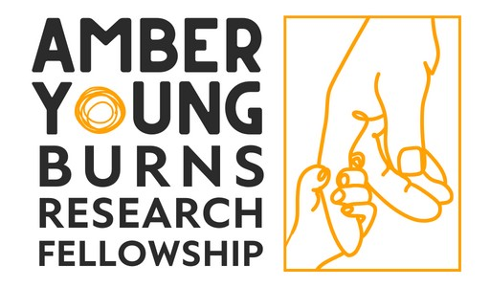
APPLICATION FORM
Please use the font size 12pt throughout. Please email one copy to charlotte@scarfree.org.uk by the closing date 5pm on the 29 APRIL 2024
Due to the volume of applications we receive, applications which do not strictly follow the instructions in this form will be rejected.
- Personal Details
Title:
Surname:
Forenames:
Address: | Post Code:
Email Address:
Phone Number:
Job Title:
Academic/Clinical Institution:

- The Project
Project Title:
Proposed Start Date:
Duration:
Participating organisation/s: | Provide full contact details of each participating organisation, to include details of NHS sponsor (if applicable).
Describe the proposed research (Max 1,500 words). This section should include:
- Background.
- Research question.
- Programme of work.
- Relevance to scope of the Amber Young Research Fellowship, i.e. research which addresses key issues of clinical burn care for children and young people aged from birth to 25 years old.
- Details of cross-service collaboration between England & Wales burns services to assist with the delivery of this project, if relevant.

(References are excluded from the word count).

Plain English summary: | Provide a lay/plain English summary suitable for a non-scientific/medical audience (max 200 words).

- Costings | (Provide a breakdown of costs for the project noting the various areas applied for).
Item:
Item:
Item:
Item:
Total

- Impact
How will this project ultimately benefit patients?
(max 350 words).

Provide information on how this research will increase your chances of attracting further grant support and the type of funding for which you intend to apply?
(max 250 words)

- Research Governance
Does this research involve animals? If yes, please email charlotte@scarfree.org.uk for further questions.

Do you need approval from your Ethics Committee or R&D department? If yes, have you obtained the necessary approvals?

- Declarations
I accept that, if the planned research has not commenced within 6 months of the award of the Fellowship, then the grant will be withdrawn.

Signed:
Print Name:
Date:

Please email this application and your CV to Charlotte Coates, charlotte@scarfree.org.uk by 5pm the 29 April 2024.

